**Assignment 1**

Name: Pallavi Dadape

Roll No.: 43239

College ID:



Problem Statement:

Using HTML5 layout tags develop an informative page with sections that include various

images, links to other pages for navigation, make use of all possible formatting (for

example font, color, etc.).

**CODES**

**home.html**

<!DOCTYPE html>

<html>

<head>

<title>One More Chapter | Your personalized online bookshelf</title>

</head>

<body>

<body style="background-color: lightcyan;">

<div align="center">

<header>

<h1 style="color:OrangeRed;"> ONE MORE CHAPTER </h1>

<font face = "WildWest" size = "5" style="color:Orchid ;">Your personalized online bookstore</font><br />

</header>

</div>

<div class="topnav">

<a href="home.html">Home</a>

<a href="books.html">Books</a>

<a href="Contact.html">Contact Us</a>

</div>

<hr >

<div align="center" >

<h2>About Us</h2>

<img src="logo.jpg" width="300" height="200">

</div>

<p> Greetings folks! </p>

<p> There are two types of people in the world. One who like reading book and the other who don't. I belong to the second category who doesn't like reading books. But this website is for the first type of people who like reading books. </p>

<p> Many a time what happens is that when we go out to buy a book from the stores, we don't realize that we already have books in our shelves at our homes and that there is no space to keep the new ones you are buying. Hence I thought of this idea - an online bookshelf. You can have your own bookshelf with all the books you wish to read from our collection. </p>

<hr >

<footer>

<p> <b> Contact information: </b> <a href="mailto:pal.dadpe@gmail.com">Pallavi Dadape</a>.</p>

<p> <b> Posted by: </b> Pallavi Dadape</p>

<p> <b> Posted by: </b> 7402629803</p>

</footer>

</body>

</html>

**books.html**  
  
<!DOCTYPE HTML>

<html>

<head>

<title> Books </title>

</head>

<body>

<body style="background-color: peachpuff;">

<div class="topnav">

<a href="home.html">Home</a>

<a href="books.html">Books</a>

<a href="Contact.html">Contact Us</a>

</div>

<hr >

<br >

<div align="center">

<header>

<h1 style="color:MidnightBlue;"> BOOKS </h1>

<br />

</header>

</div>

<div>

<h2>Fiction</h2>

<a href="Fiction.html">

<img src="fiction.jpg" alt="Fiction" width="700" height="500">

</a>

</div>

<hr >

<div>

<h2>Crime</h2>

<a href="Crime.html">

<img src="crime.jpeg" alt="Crime" width="700" height="500">

</a>

</div>

<footer>

<p>Contact information: <a href="mailto:pal.dadpe@gmail.com">Pallavi Dadape</a>.</p>

<p>Posted by: Pallavi Dadape</p>

<p>Posted by: 7402629803</p>

</footer>

</body>

</html>

**crime.html**

<!DOCTYPE HTML>

<html>

<head>

<title> Crime Genre </title>

</head>

<body>

<body style="background-color: lavender;">

<div class="topnav">

<a href="home.html">Home</a>

<a href="books.html">Books</a>

<a href="Contact.html">Contact Us</a>

</div>

<hr >

<br >

<div align="center">

<header>

<h1 style="color:OrangeRed;"> CRIME </h1>

<br />

</header>

</div>

<div align="left">

<a href="https://books.google.co.in/books/about/The_Hound_of_the_Baskervilles.html?id=ePVcDwAAQBAJ&printsec=frontcover&source=kp_read_button&redir_esc=y#v=onepage&q&f=false">

<img src="baskervilles.jpg" width="200" height="300">

<br >

Title: The Hound of the Baskervilles

<br >

Author: Sir Arthur Conan Doyle

</div>

<div align="center">

<a href="https://www.goodreads.com/book/show/16325.Partners_in_Crime">

<img src="partners in crime.jpg" width="200" height="300">

<br >

Title: Partners in Crime

<br >

Author: Agatha Christie

</div>

<div align="right">

<a href="https://danbrown.com/the-davinci-code/">

<img src="vincicode.jpg" width=200" height="300">

<br >

Title: The Da Vinci Code

<br >

Author: Dan Brown

</div>

<footer>

<p>Contact information: <a href="mailto:pal.dadpe@gmail.com">Pallavi Dadape</a>.</p>

<p>Posted by: Pallavi Dadape</p>

<p>Posted by: 7402629803</p>

</footer>

</body>

</html>

**fiction.html**

<!DOCTYPE HTML>

<html>

<head>

<title> Fiction Books </title>

</head>

<body>

<body style="background-color: lavender;">

<div class="topnav">

<a href="home.html">Home</a>

<a href="books.html">Books</a>

<a href="Contact.html">Contact Us</a>

</div>

<hr >

<br >

<div align="center">

<header>

<h1 style="color:OrangeRed;"> FICTION BOOKS </h1>

<br />

</header>

</div>

<div align="left">

<a href="https://www.pdfdrive.com/the-lord-of-the-rings-e12211928.html">

<img src="lord of rings.jpg" width="200" height="300">

<br >

Title: Lords of Rings

<br >

Author: J. R. R. Tolkien

</div>

<div align="center">

<a href="https://www.goodreads.com/book/show/36203372-smoke-and-ashes">

<img src="smoke and ashes.jpg" width="200" height="300">

<br >

Title: Smoke and Ashes

<br >

Author: Abir Mukherjee

</div>

<div align="right">

<a href="https://www.goodreads.com/book/show/36203372-smoke-and-ashes">

<img src="wimpy kid.jpg" width=200" height="300">

<br >

Title: Diary of a Wimpy Kid

<br >

Author: Jeff Kinney

</div>

<footer>

<p>Contact information: <a href="mailto:pal.dadpe@gmail.com">Pallavi Dadape</a>.</p>

<p>Posted by: Pallavi Dadape</p>

<p>Posted by: 7402629803</p>

</footer>

</body>

</html>

**Contact.html**

<!DOCTYPE html>

<html>

<head>

<title> Contact Us </title>

</head>

<body>

<body style="background-color: lightcyan;">

<div align="center">

<header>

<h1 style="color:OrangeRed;"> ONE MORE CHAPTER </h1>

<font face = "WildWest" size = "5" style="color:Orchid ;">Your personalized online bookstore</font><br />

</header>

</div>

<div class="topnav">

<a href="home.html">Home</a>

<a href="books.html">Books</a>

<a href="contact.html">Contact Us</a>

</div>

<p> <b> Contact information: </b> <a href="mailto:pal.dadpe@gmail.com">Pallavi Dadape</a>.</p>

<p> <b> Posted by: </b> Pallavi Dadape</p>

<p> <b> Posted by: </b> 7402629803</p>

</html>

**SCREENSHOTS**

Screen1 -

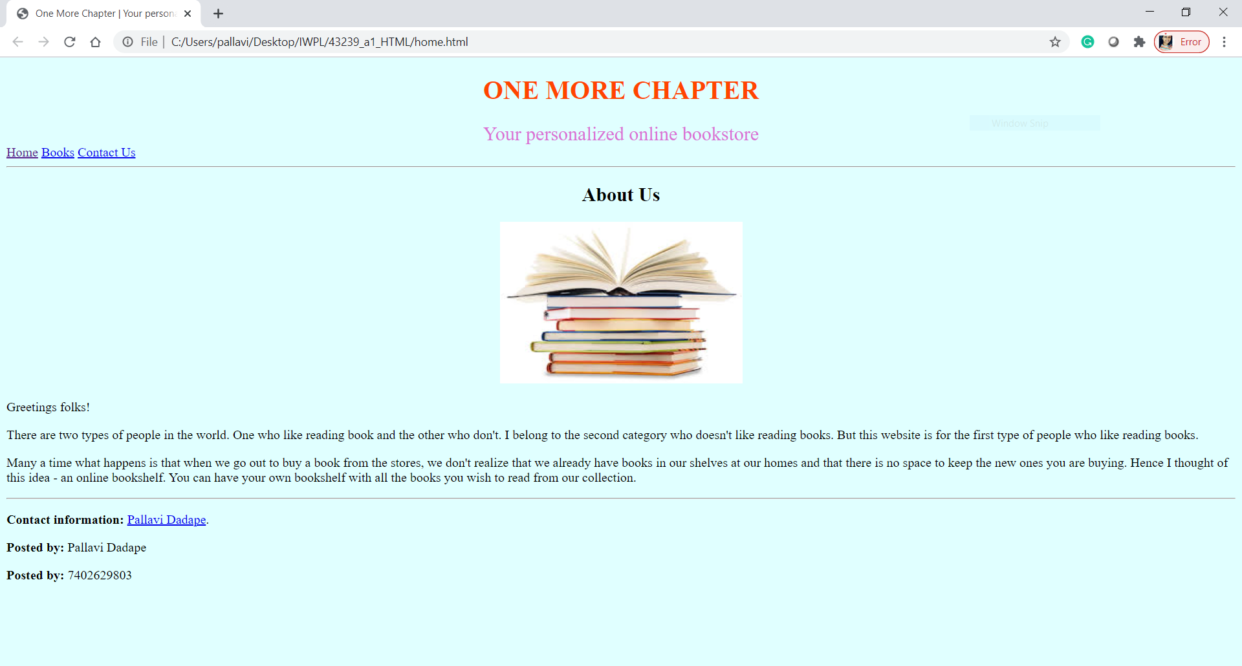

Screen2 -

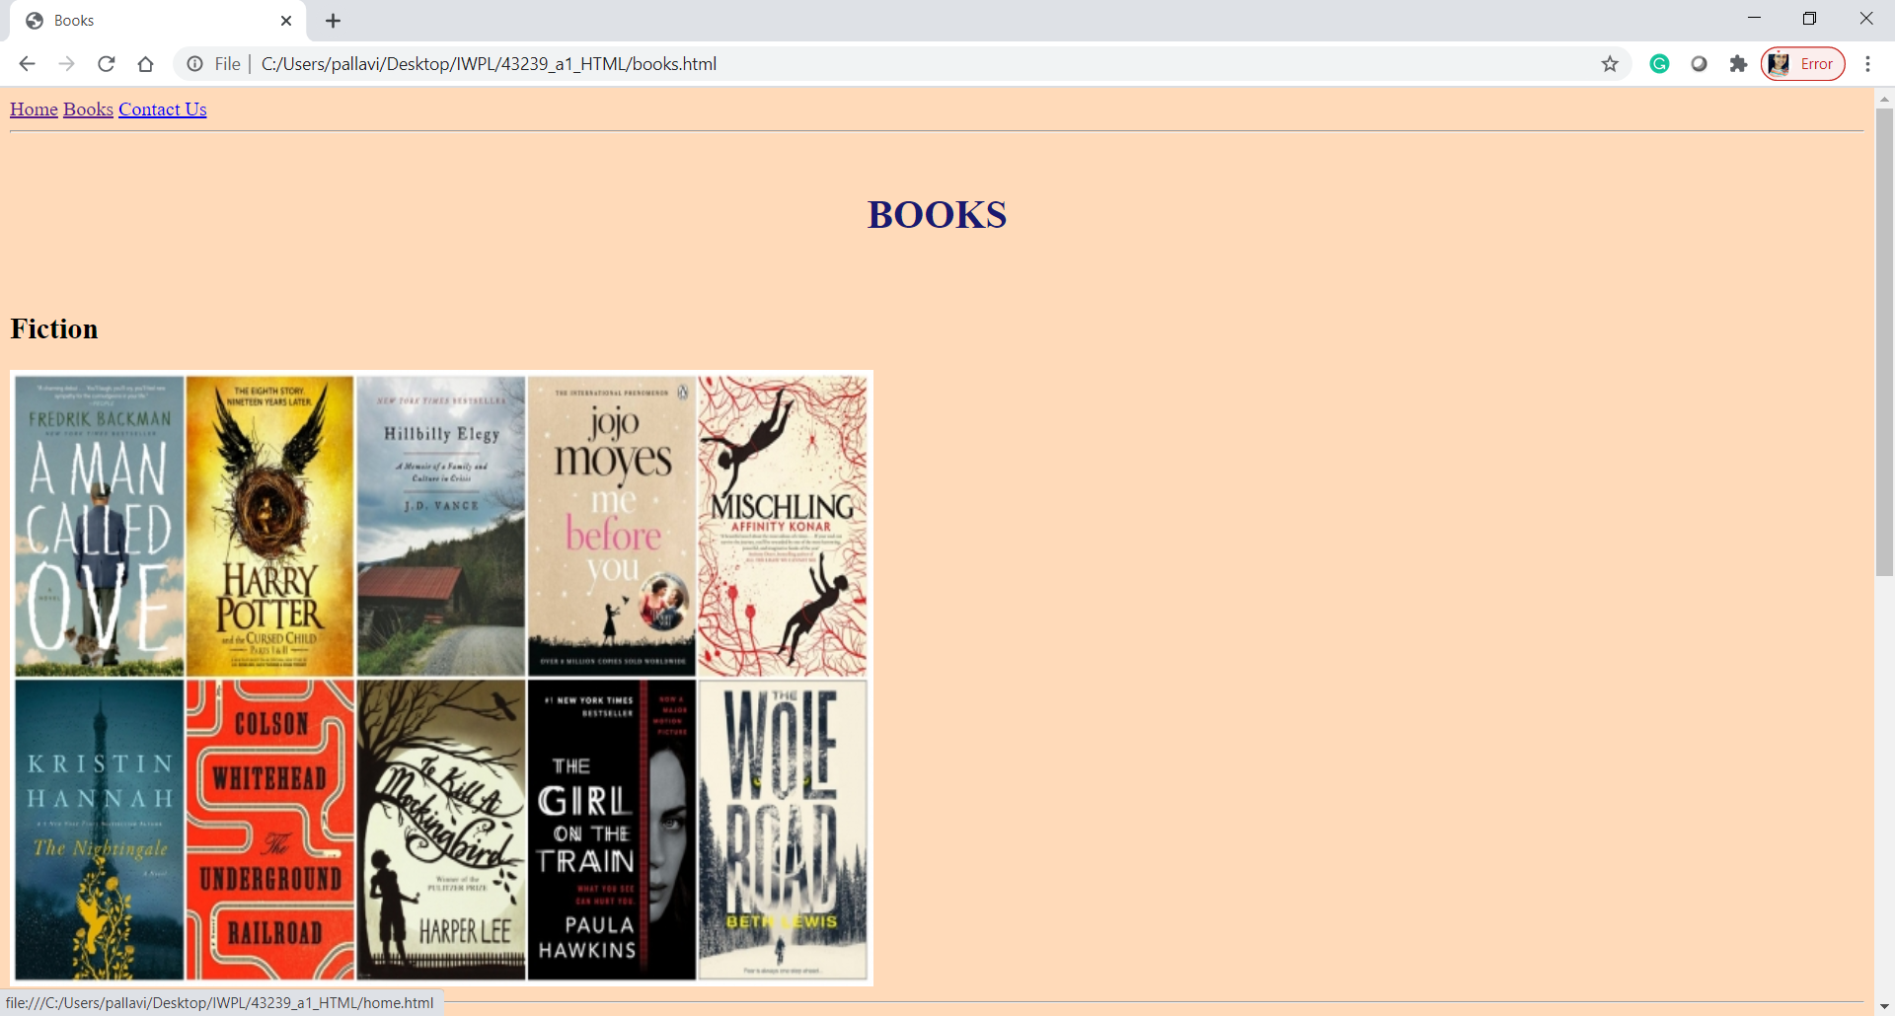

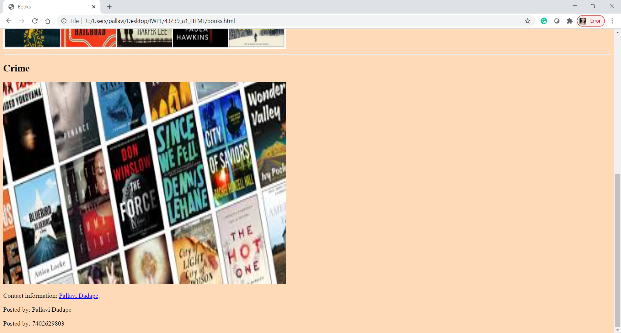

Screen3.1 -

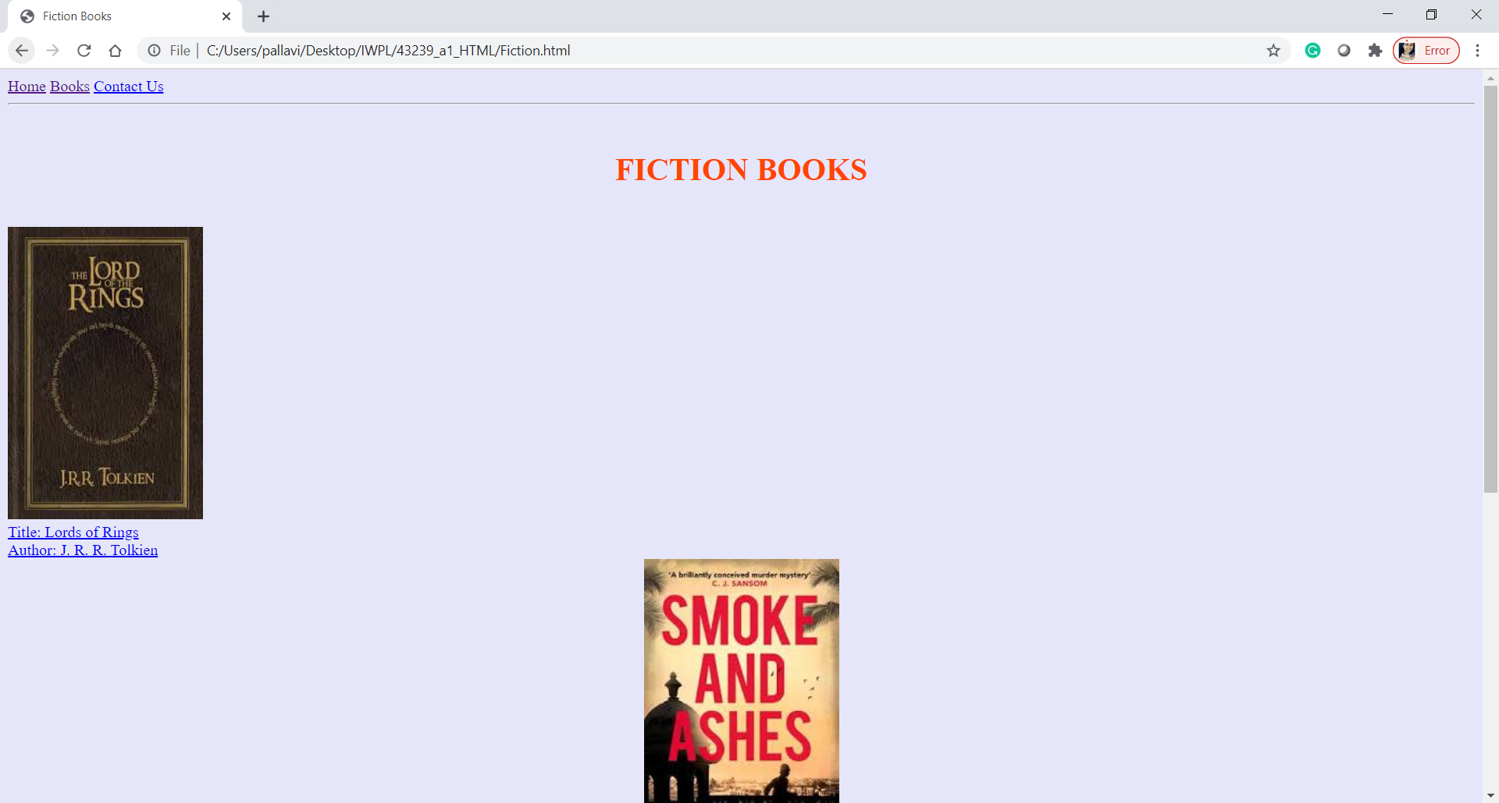

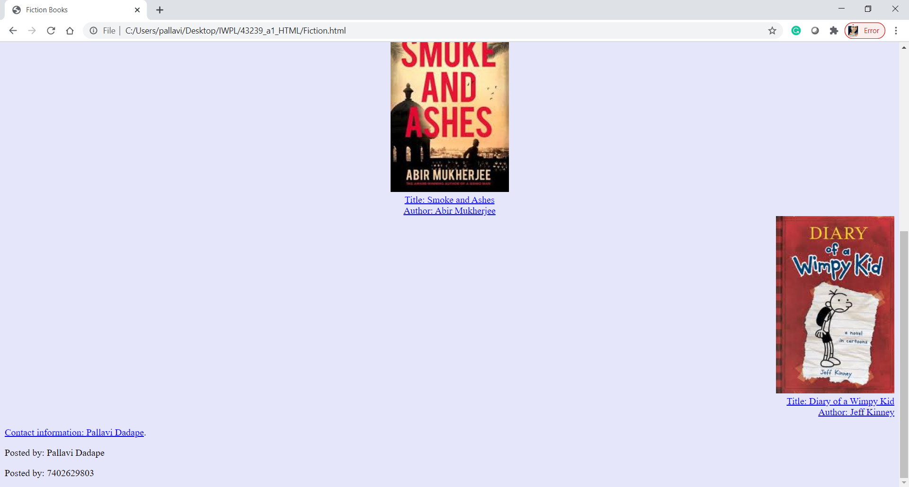

Screen 3.2 -

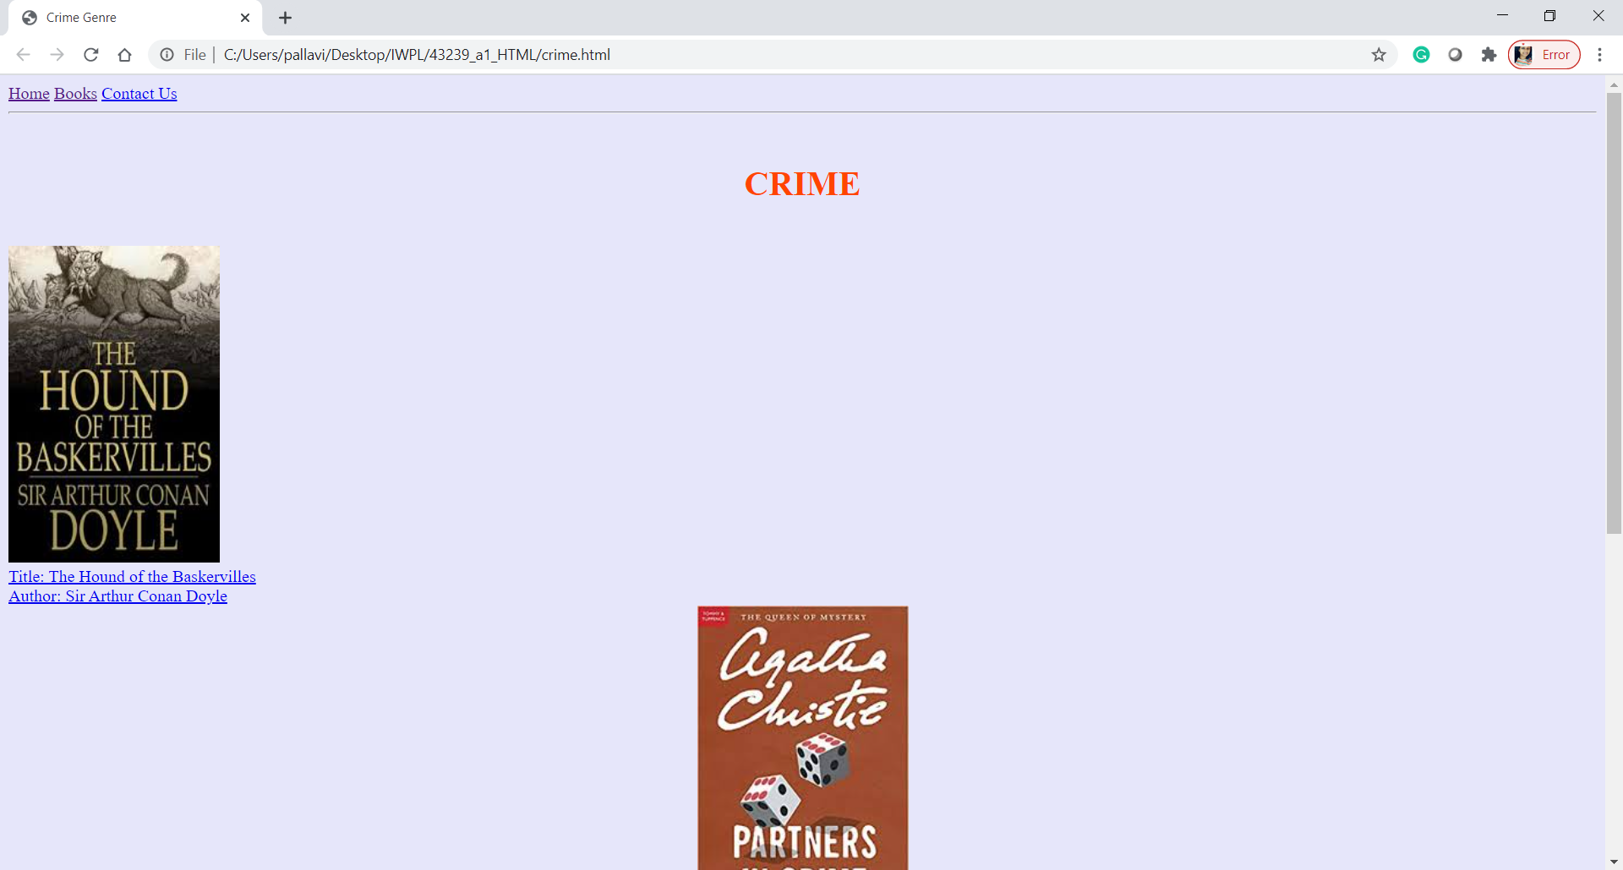

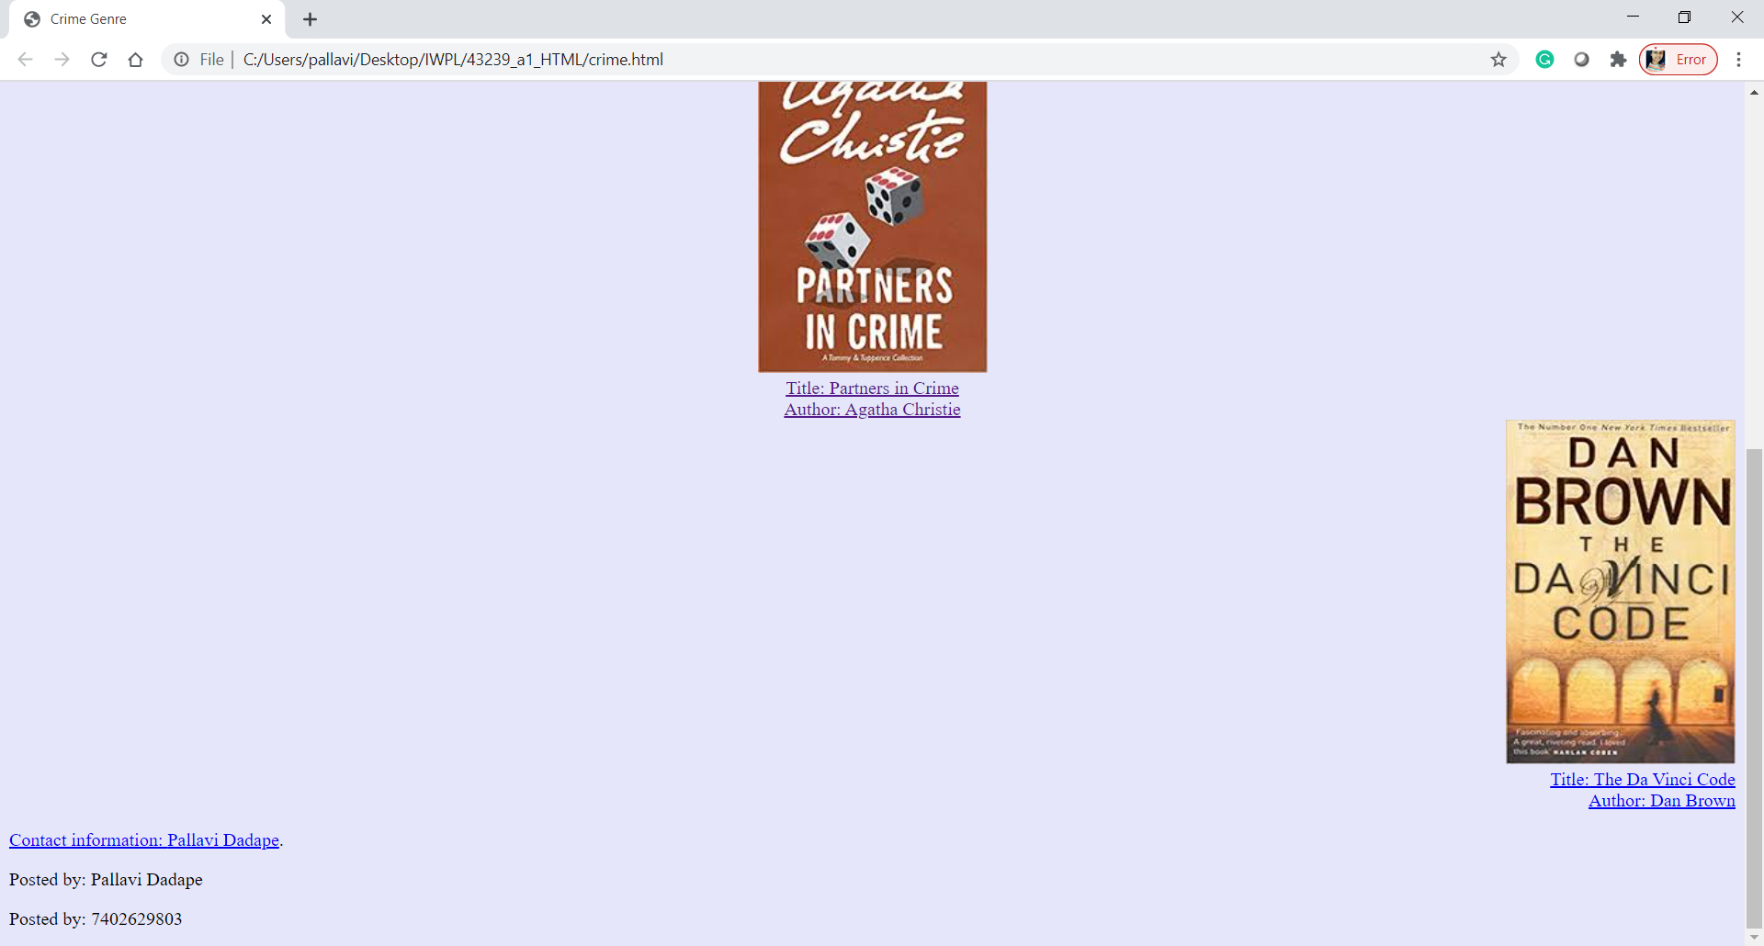

Screen4 -

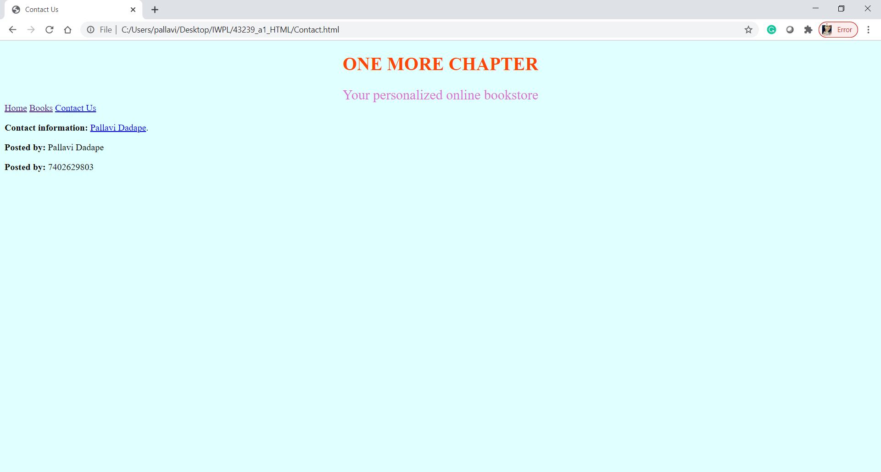

Conclusion

Thus, I have successfully implemented this assignment by using html to make a book store website.